**Data structures and algorithms**

**LAB# 01**

|  |  |
| --- | --- |
| **Name** | MOHSIN RAZA |
| **Registration Number** | 200901052 |
| **Batch & Section** | CS (01)-A |
| **Instructor’s Name** | Sir Nadeem |
| **Date** | 23rd Oct, 2021 |

**Lab task # 01:**

I have added a code for help but don’t submit your tasks with the same code.

**CODE:**

a=input("enter a string : ")

b=a[::-1]

if(a==b):

print("\nstring is a palindrome\n")

else:

print("\nstring is not palindrome \n")

**OUTPUT:**

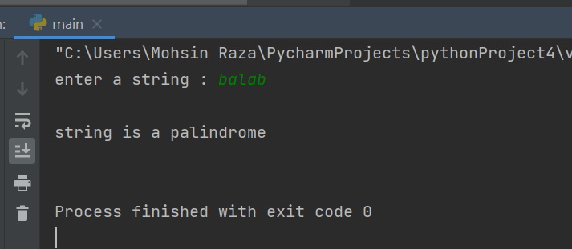

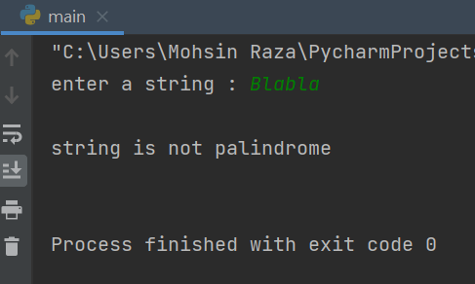

**Lab Task # 02:**

Write a program to check the balanced parenthesis in the expression or not using stack.

**CODE:**

from collections import deque

eq = input("Enter any equation: ")

stack = deque()

result = "Equation balanced"

counter = 0

for i in eq:

if (i == '(' or i == '[' or i == '{'):

stack.append(i)

counter = counter + 1

elif (i == ')' or i == ']' or i == '}'):

if (len(stack) != 0):

if (i == ')'):

if(stack[-1] == '('):

counter = counter - 1

if (i == ']'):

if (stack[-1] == '['):

counter = counter - 1

if (i == '}'):

if (stack[-1] == '{'):

counter = counter - 1

stack.pop()

else:

result = "Equation unbalanced!"

break

if (counter != 0):

result = "Equation unbalanced"

print (result)

**OUTPUT:**

